**Developing RESTful API using Java**

**IDE used:**

Eclipse IDE for Enterprise Java Developers.

Version: 2019-12 (4.14.0)

Download Eclipse IDE from <https://www.eclipse.org/downloads/packages/>

The suitable package for this implementation is “ Eclipse IDE for Enterprise Java Developers” :

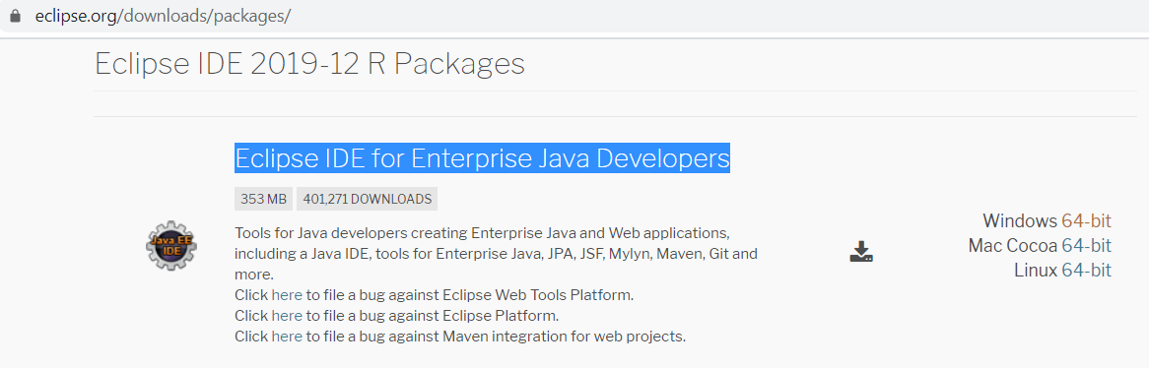

**Step 1:**

Install Apache Tomcat server from <https://tomcat.apache.org/download-80.cgi>

Direct download link (for Windows): <http://apachemirror.wuchna.com/tomcat/tomcat-8/v8.5.51/bin/apache-tomcat-8.5.51.exe>

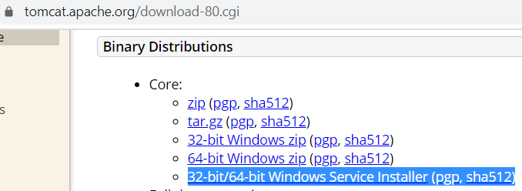

**Step 2:**

Download Jersey RESTful Web Services from <https://eclipse-ee4j.github.io/jersey/download.html>

Jersey JAX-RS 2.1 RI bundle direct download link: <http://repo1.maven.org/maven2/org/glassfish/jersey/bundles/jaxrs-ri/2.30/jaxrs-ri-2.30.zip>

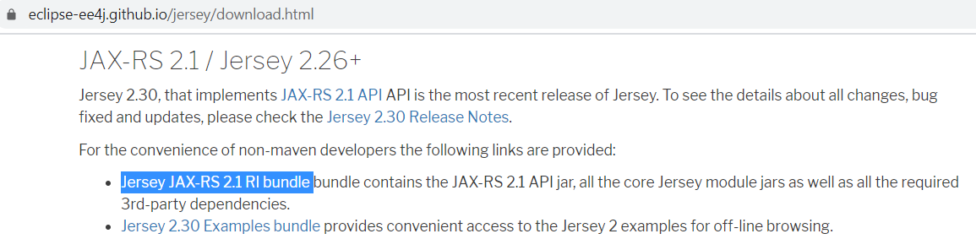

Alternatively, it can also be downloaded from <https://jar-download.com/artifacts/org.glassfish.jersey.bundles/jaxrs-ri/2.1/source-code>

Step 3: Open Eclipse IDE

Some useful links

Setting up tomcat : <https://www.youtube.com/watch?v=PH-bK3g2YmU>

Building RESTful API (reference): <https://www.youtube.com/watch?v=5jQSat1cKMo>

**REST/RESTful Web Services**

- REST stands for Representational State Transfer. It’s an architectural pattern for creating web services. - A RESTful service is one that implements that pattern.

- REST Client applications can use HTTP GET/POST/PUT/DELETE methods to invoke Restful web services.

**Java RESTful Web Services API**

Java API for RESTful Web Services (JAX-RS) is the Java API for creating REST web services. JAX-RS uses annotations to simplify the development and deployment of web services. JAX-RS is part of JDK, so you don’t need to include anything to use it’s annotations.

**Restful Web Services Annotations**

Some of the important JAX-RS annotations are:

* @Path: used to specify the relative path of class and methods. We can get the URI of a webservice by scanning the Path annotation value.
* @GET, @PUT, @POST, @DELETE and @HEAD: used to specify the HTTP request type for a method.
* @Produces, @Consumes: used to specify the request and response types.
* @PathParam: used to bind the method parameter to path value by parsing it.

**REST API Implementations**

There are two major implementations of JAX-RS API.

1. **Jersey**: [Jersey](https://jersey.github.io/) is the reference implementation provided by Sun. For using Jersey as our JAX-RS implementation, all we need to configure its servlet in web.xml and add required dependencies. Note that JAX-RS API is part of JDK not Jersey, so we have to add its dependency jars in our application.
2. **RESTEasy**: [RESTEasy](https://resteasy.github.io/" \t "_blank) is the JBoss project that provides JAX-RS implementation.

**Output**

(Error 404 - Page not found :O… some err in path…)

